**Project Report Template**

**Title of Project:** Support System for Single Mothers  
**Name of the Innovator:** Punya K V  
**Start Date:** 27-10-2025

**End Date: 31-10-2025**

***Day 1: Empathise & Define***

*Step 1: Understanding the Need*

* Which problem am I trying to solve?
* Who is affected by this problem?

I’m solving the problem that helps to solve is the **lack of accessible** and **organized support** (emotional, financial, social, and educational) that single mothers often face.

* How did I find out about this? [Select whichever is applicable]
* Interviews
* Observation
* Online Research
* AI Tools

*Step 2: What is the problem?*

Single mothers face multiple challenges in **balancing family responsibilities**, **income generation, and personal well-being** — often without sufficient social or institutional support.

Why is this problem important to solve?

Many single mothers **experience loneliness, stress, and depression** due to lack of emotional support or social stigma. Difficulty finding stable jobs or financial assistance while caring for children alone.

**Take-home task**

Ask 2-3 people what they think about the project:

* **1. Student (Rural College Student):**  
  **“I think your project is very meaningful. Many single mothers struggle emotionally and financially, so a digital support system would really help them. You could also add features for counseling and child education support.”**
* **2. Teacher (Career Guidance Teacher):**  
  “It’s a socially impactful project. You’re addressing a real problem that often goes unnoticed. Try to make your platform simple to use, especially for mothers who may not be very familiar with technology.”
* **3. Parent (From a Rural Area):**  
  “As a single mother myself, I feel this is an excellent idea. Sometimes we just need guidance or someone to talk to. If this app offers emotional support and helps find jobs, it will change many lives.”

*AI Tools you can use for Step 1 and 2:*

**AI Tools Used:**

**1. Meta MGX**

* Used as a no-code development tool to design and deploy the **Rising Strong**  app.
* It helps create interactive workflows, user interfaces, and logic without programming.
* Ideal for building features like user registration, location-based data, and skill modules.

**2.ChatGPT**

* Used for idea generation, content structuring, and chatbot conversation design.
* Helped in framing the AI-powered virtual assistant’s responses for guiding students.
* Also useful for generating career recommendations, FAQs, and improving user interaction flow.

**3. Chatbot References (Structure Design):  
To design the AI virtual assistant, you can take reference from:**

* Google Dialogflow – for understanding intent detection and response flow.
* IBM Watson Assistant – for creating structured Q&A and personalized career guidance.
* Microsoft Bot Framework – for understanding conversation trees and user profile integration.

***Day 2: Ideate***

*Step 3: Brainstorming solutions*

* List **at least 5 different solutions** (wild or realistic):
* **AI Chatbot for Emotional Support** – Provides 24/7 counseling, motivation, and guidance to help single mothers cope with stress and challenges.
* **Skill Learning Website** – Offers free online courses and workshops to help single mothers gain employable skills and improve career opportunities.
* **Mobile App for Scholarships and Jobs** – Shares updates about scholarships, job openings, and financial aid specifically for single mothers.
* **Community Mentor Program** – Connects single mothers with experienced mentors who can provide advice, support, and networking opportunities.
* **Childcare Assistance Network** – Helps single mothers find affordable and safe childcare options so they can balance work, study, and family life.

*Step 4: My favourite solution:*

My favourite solution of the **Rising Strong**  App because it focuses on helping women who handle both parenting and **livelihood responsibilities on their own.** Many single mothers face emotional struggles, financial problems, and lack of proper guidance. This solution provides them with a complete **support network** that improves their lives in different ways

*Step 5: Why am I choosing this solution?*

I chose the **Rising Strong**  App for Single Mothers because I believe that single mothers are among the most hardworking yet often overlooked members of society. They face many challenges — emotionally, financially, and socially — while taking care of their families alone. Many of them struggle to balance work, childcare, and personal life without enough guidance or support. This solution provides a strong helping hand by giving them access to resources, counseling, financial aid, job opportunities, and emotional support — all in one platform.

*AI Tools you can use for Step 3-5:*

**AI Tools for Step 3–5**

**1. Meta MGX**

* Used to design and build **the Rising Strong**  App **for** Single Mothers without coding.
* Helps create the **AI assistant, skill modules, and location-based features**.

**2. ChatGPT**

* Helps **brainstorm solutions** and generate ideas for career guidance features.
* Can **structure conversations** for the AI virtual assistant.
* Assists in writing content for skill modules, FAQs, and recommendations.

**3. AI Chatbot References (for design and flow)**

* **Dialogflow** – Understands user intent and conversation flow.
* **IBM Watson Assistant** – Helps design structured Q&A for personalized guidance.
* **Microsoft Bot Framework** – Shows how to connect user inputs with recommendations and actions.

**4. AI Research Tools**

* **Google Scholar / Research AI** – For exploring existing solutions and innovative ideas for Steps 3–5.
* **AI Text & Summarization Tools** – Helps summarize solutions, select the best approach, and present them clearly.

*AI Tools you can use for the take-home task:*

**Canva AI/CoPilot AI/Meta AI:** Use these mobile-based tools to generate images for the solution they want to design

***Day 3: Prototype & Test***

*Step 6: Prototype – Building my first version*

What will my solution look like?

* **A Mobile App / Website Platform:** A user-friendly digital space where single mothers can easily access emotional, financial, and community support anytime.
* **Emotional & Mental Health Support**:Built-in chat or AI counselor for motivation, stress management, and mental wellness guidance.
* **Job & Skill Development Section:** A space that offers online courses, job listings, and career guidance to help mothers become financially independent.
* **Community Forum:**A safe online community where single mothers can connect, share experiences, and support each other.
* **Information & Emergency Help**:Quick access to government schemes, scholarships, legal aid, and emergency helplines for safety and assistance**.**

**Design Style:**

* Simple, intuitive, and easy to navigate for single mothers
* Bright and engaging visuals to make browsing and exploration easier.
* Mobile-friendly layout for easy access on smartphones.

**Prototype Tools:**

* Built using **Meta MGX**, no coding required, with all features **interactive and testable**.

What AI tools will I need to build this?

**AI Tools Needed to Build Support System For Single Mothers**

1. **Meta MGX**
   * No-code platform to **design and deploy the app**.
   * Allows building **interactive screens, chat interfaces, and skill modules** without coding.
2. **ChatGPT (or similar LLMs)**
   * To **generate content, conversation flows, and guidance responses**.
   * Can help **personalize recommendations** for users based on their profile and location.
3. **AI Chatbot Design References**
   * **Google Dialogflow / IBM Watson Assistant / Microsoft Bot Framework**
   * To **structure conversation logic** and handle user queries effectively.

What AI tools I finally selected to build this solution?

1. **Chat GPT**
2. **Metamgx**

**< Build The Innovation>**

**<DASHBOAD OF THE TOOL>**

**Tool Link:**  <https://mgx-rd2btlcio5s.mgx.world>

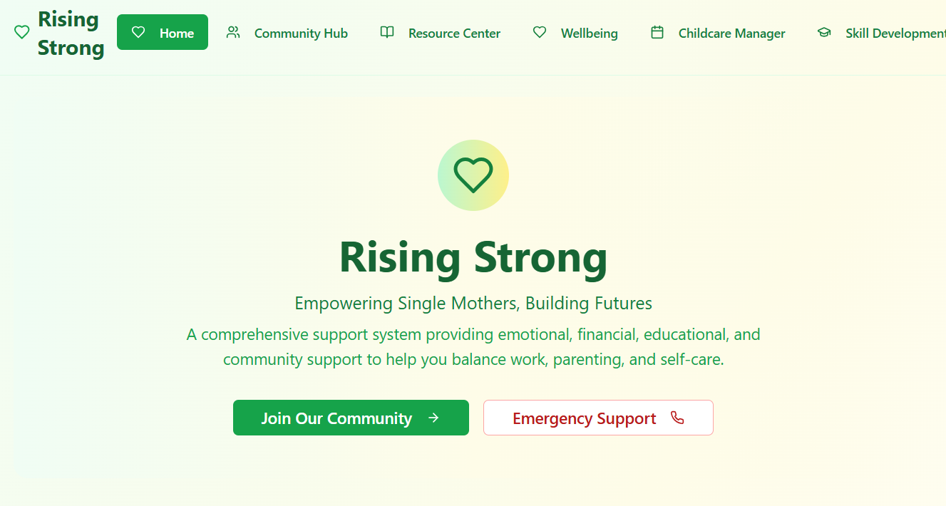

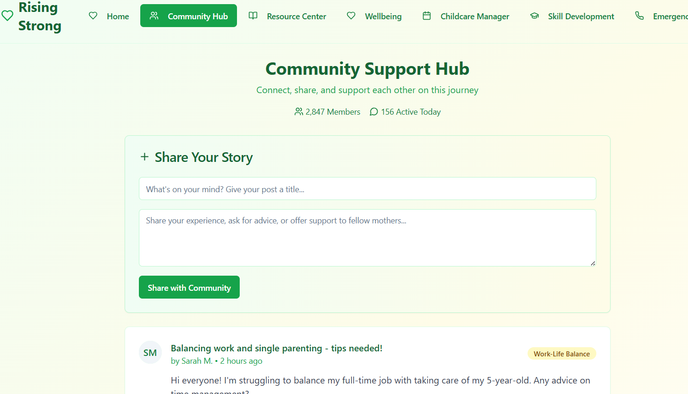

Internal Working of tool:

Profile Creation: 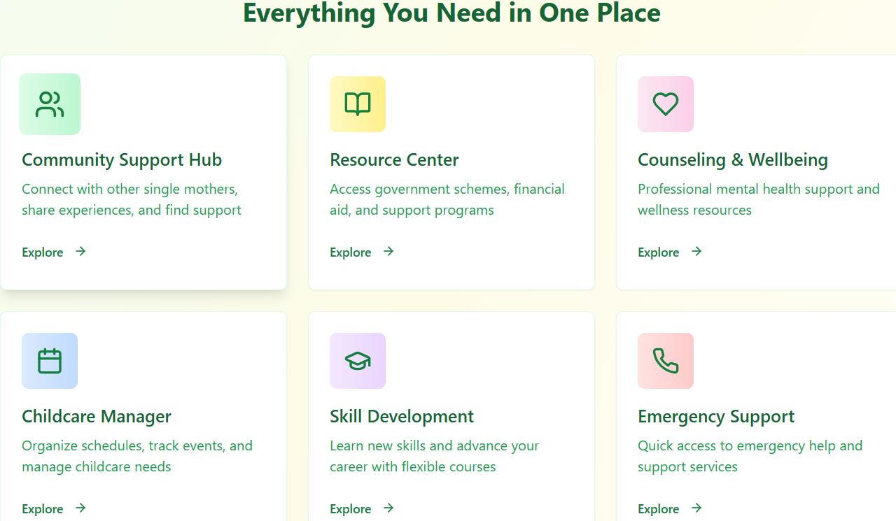

*Step 7: Test – Getting Feedback*

* Who did I share my solution with?

I shared my **Support System For Single Mothers** solution with:

* **Students from rural areas** – to get feedback on usability and relevance.
* **Teachers and career guidance counselors** – to understand how well it supports single mothers.
* **Parents of rural students** – to see if it helps families access information about guidance and accessability.
* **Peers and mentors** – for suggestions on improving features and design.

What feedback did I receive?

**Feedback: Pros and Cons**

**Pros (Positive Insights from Feedback):**

1. Provides emotional and financial support to single mothers.
2. Helps improve skills and job opportunities.
3. Creates a strong, supportive community network.

**Cons (Areas to Improve Noted in Feedback):**

1. Requires internet and smartphone access.
2. Needs regular updates and maintenance.
3. May have privacy and data security concerns.

**My Response for The Feedback:**

I received positive feedback for my project “Support System for Single Mothers.” Many people appreciated that it focuses on emotional, financial, and social support for single mothers. They suggested including features like counseling, job opportunities, and an easy-to-use design. I agree with their feedback because it helped me understand how to make the system more useful and realistic. Based on the suggestions, I plan to add a chat support feature, skill development options, and a secure, user-friendly interface. This feedback encouraged me to improve my project and make it more impactful for single mothers in real life.

👍 What works well:

**What Works Well**

1. **Community Support:** Builds a strong network where single mothers can connect, share experiences, and help each other.
2. **Skill Development:** Offers training programs to improve employability and financial independence.
3. **AI Chatbot Assistance:** Provides 24/7 guidance on jobs, scholarships, and emotional support.
4. **User-Friendly Platform:** Easy to use and accessible on both mobile and web for all age groups.
5. **Access to Resources:** Gives real-time updates on scholarships, workshops, and local opportunities.
6. **Empowerment and Confidence:** Encourages self-reliance and emotional well-being through continuous support and learning.

🔧 What needs improvement:

1. **Awareness and Reach:** More promotion is needed to ensure single mothers in remote areas know about the platform.
2. **Funding and Resources:** Additional financial support could help expand training programs and improve content quality.
3. **Technical Accessibility:** The app should work smoothly even with low internet connectivity.
4. **Personalization:** The AI chatbot could offer more customized advice based on individual needs and situations.
5. **Partnerships:** Building collaborations with NGOs, employers, and government programs can increase real-world impact.
6. **Language Options:** Adding multiple regional languages would make the platform more inclusive and user-friendly.

*AI Tools you can use for Step 6-7:*

**ChatGPT/Perplexity AI/Claude AI/Canva AI/Chatling AI/Figma AI/Metamgx/Gamma AI**: You can use these tools to build solutions/models or mock-up dummy prototypes

***Day 4: Showcase***

*Step 8: Presenting my Innovation:*I am presenting the **“Support System for Single Mothers”**, through **Rising Strong App** a digital platform designed to empower and assist single mothers in their personal and professional growth.

It features:  
• **An AI-powered chatbot** that provides personalized guidance on jobs, scholarships, and emotional support.  
• **Skill development programs** focused on communication, financial literacy, and digital skills to enhance employability.  
• **Community mentorship networks** connecting single mothers with mentors and peer groups for motivation and guidance.  
• **Real-time updates** on scholarships, government schemes, and local opportunities to support financial independence.  
• **A user-friendly, mobile-friendly platform** accessible anytime, offering continuous learning and lifetime access.

**Impact:** The “*Support System for Single Mothers”* has a powerful impact by **empowering women to become independent and confident** through access to education, employment, and emotional support. It **reduces financial stress**, **improves skill development**, and **creates a strong community network**, helping single mothers build stable lives and secure brighter futures for themselves and their children.

**<SHOWCASE YOUR INNOVATION TO YOUR PEERS>**

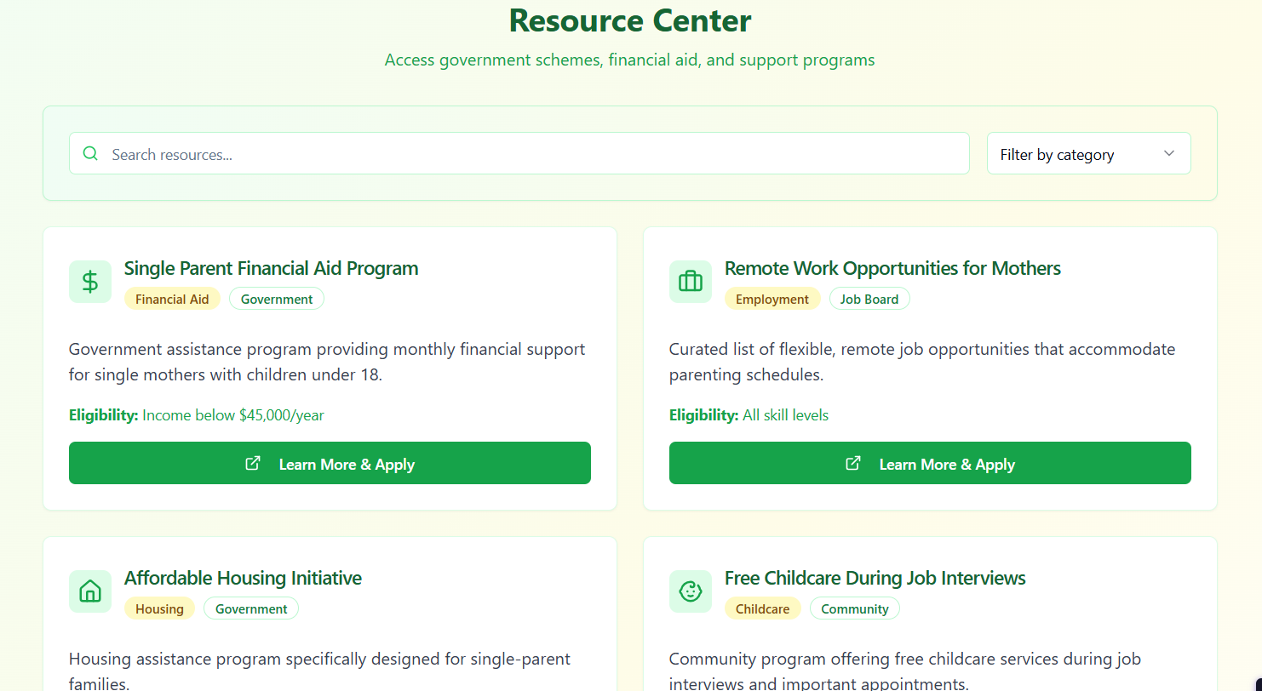

*Step 9: Reflections*

* What did I enjoy the most during this project-based learning activity?

I enjoyed **creating a meaningful solution that supports and uplifts single mothers** through technology. Working on this project allowed me to combine creativity, empathy, and digital innovation to make a real social impact. I especially liked **designing the AI chatbot and mentorship features**, as they showed how technology can bring hope, guidance, and empowerment to those who need it most.

* What was my biggest challenge during this project-based learning activity?

My biggest challenge during this project-based learning activity was **understanding the real needs and struggles of single mothers** to design a system that truly helps them. It was also challenging to **balance technical features like AI and community support** while keeping the platform simple and accessible. Overcoming these challenges taught me the importance of **research, empathy, and user-centered design** in creating impactful solutions.

**Take-home task**

[*https://github.com/punya-231/Support-System-For-Single-Mothers*](https://github.com/punya-231/Support-System-For-Single-Mothers)

*AI Tools you can use for Step 8:*

**Canva AI:** You can use this to design your pitch document. Download your pitch document as a PDF file and upload on GitHub